HEAVY M.E.T.A.L FUNDRAISING EVENT
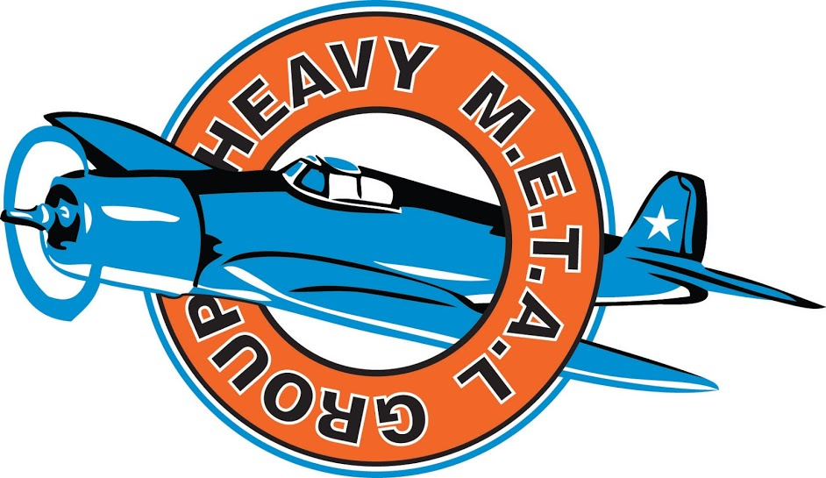

The HEAVY M.E.T.A.L Group
is participating in the taste testing of meat for the Meat Standards of Australia (MSA)

- Participants must be between 18 - 70 year olds
- who eat red meat at least once a fortnight
- who enjoy meat cooked medium rare to medium well done

Please come along to this meat tasting night to raise $1000
Date: Friday 4th August 2017
Venue: Hallam Senior College,
Sawrey’s Gallery Restaurant
Frawley Road - Hallam
Times: 6:00pm, 7:00pm or 8:00pm
Contact David Nugent on 0401766877 to book in your session

